**Assignment #3 Reflection**

**Names:**Panagiota Fytopoulou (30048280)

Jaedwin Montal (30012238)

**Project Title:**

Water Plant vs. Coffee Zombie

**GitHub Link (Code):**

<https://github.com/PanagiotaF/CPSC599.88A3/tree/master/FlowerZombie>

**Portfolio Link:**

<https://panagiotafytopoulo.wixsite.com/mysite/project-03>

**Screenshot of Portfolio Page**

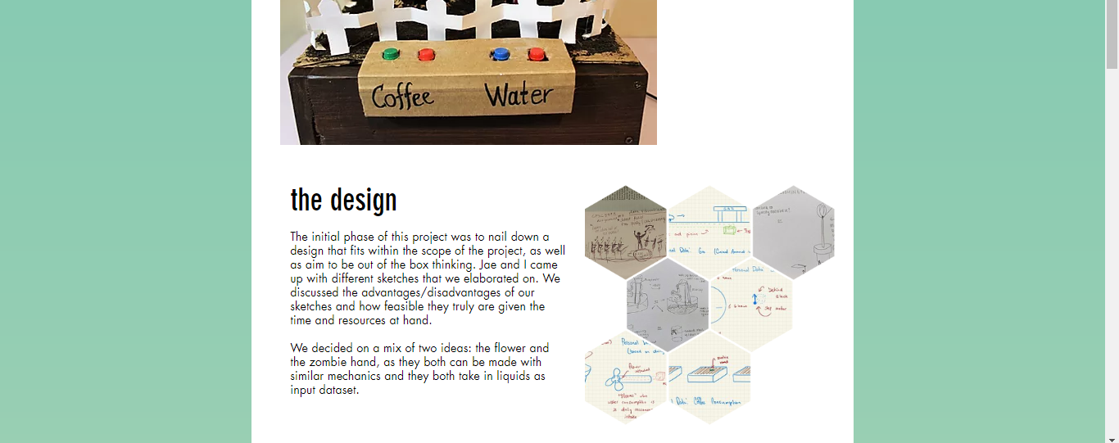

**Reflection:**

1. **Approximate Time Spent:** 
   1. Designing & Sketching: ~2 Hours
   2. Prototyping: ~10 Hours
      1. Mostly due to 3d print times and prototyping
   3. Assembly: ~5 Hours
   4. Testing: ~1 Hour
2. **What We Learned**
   1. Using step motors (specifically 28BYJ-48)
   2. Physically moving objects with the above motor
   3. Prototyping physical/moving parts to work together (specifically rack and pinions)
   4. Using Arduino’s to physically control motors
3. **Advice for Future Students**
   1. Spend a lot of time figuring out how you want things to work in the real world, if you are designing a system to work together (a gear and another object) then plan how you want those objects to work together and make sure to take gravity, object weight, and motor strength into consideration
   2. Have multiple designs readily available to understand what can be accomplished in the given time, don’t be afraid to use parts of certain designs to form something achievable
   3. Use resources available (YouTube, Stack Overflow) to find solutions to problems that have answers readily available – For example with the step motor we wanted to use there was uncertainty on how to program it correctly but only solutions already proved to be practical. Make sure to credit it. Adapt and use the solutions to your needs.